TESTING SECTION

Test Plan

Test No | Description | Reason for test
1. Valid data | Erroneous and or valid data.  Testing data that should not pass validation/regex validation – such as invalid URLs/password or that WILL pass validation. | Analysis section 3.2 (Specific Objective 1.d.i), the system should cater for only certain types of data: URL data, and valid URL data (no metadata, for example).
2. Malicious data | Malicious data.  Data that could potentially harm the HQ platform or the user’s data. | Analysis section 3.2 (Specific Objective 2.a), malicious data should NOT be handled to the database.
3. Database test | Make sure all data returned from the database is correct, correctly displayed, and fetched in reasonable time. | Independent test – this test is to make sure ALL data processed by Eyespy is validated and correctly inserted into the database.
4. Data structure test | Ensure the stack data structure is working within the required stack frame. | Make sure the robustness of the data structure is sufficient for the context.
5. Data structure test | Modular testing – each mechanical function of the Eyespy Core module will be tested. | Modules inside the Eyespy Core include resetting the hitcoounter, website entries, and erasing all data. These operations are performed by clicking on the appropriate button in the Configuration tab. These tests will ensure these modules work.

Test data charts

TEST 1 (erroneous and valid data)

FORM NAME: Eyespy HQ Authentication
FUNCTION: to allow users to log on
Input | Expected result | Result achieved | Test ref.
Valid password in correct format (password = admin) | Redirects to main page | Yes | T1
No password | Message "Incorrect password/password format." | Yes | T1
Password = asdf (invalid data) | Message "Invalid username/password." | Yes | T1

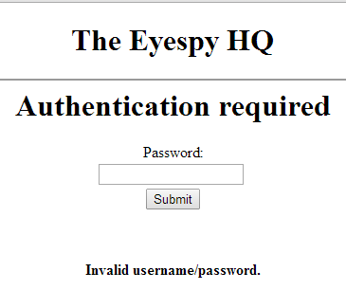
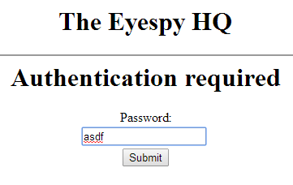
Valid data testing performed on Eyespy HQ.
Figure 1, T1 - Invalid password CAUSE
Figure 2 - T1, Invalid Password EFFECT

FORM NAME: Eyespy Core
FUNCTION: Intercepts HTTP requests and gets HTML dump from incoming traffic
Input | Expected result | Result achieved | Test ref.
Notify4.dropbox.com  Accept-Encoding: Identity  Connection: keep-alive  X-Dropbox-Locale: fr | Message box saying that the link is invalid and/or too long and could cause the program to crash (buffer overflow).  Although, in the released version, no message box will be printed – the URL will just be ignored. | Yes | T2.1
No URL | Message box displaying lack of URL.  Although, in the released version, no message box will be printed – the URL entry will just be ignored. | Yes | T2.2

The following messages are issued by Eyespy Core, valid data.
Figure 3 - T2.1, Invalid URL
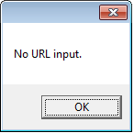
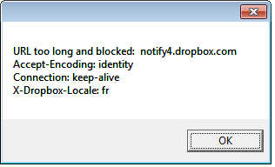
Figure 4 - T2.2, No URL submitted

FORM NAME: Submit.php
FUNCTION Submit URL and site data to the database
Input | Expected result | Result achieved | Test ref.
URL visited: http://google.com/ | Information for URL is submitted or updated  (entry_udpdated or entry_submited) | Yes | T3
Link visitd: asdsad | Message regex_no for asdasd | Yes | T3
Link visited: Google. | Message regex_no for Google. | Yes | T3

The following messages are issued by Submit.php, the URL submission/validation PHP script.

Result when URL submitted to the Submit.php script is VALID. T3, valid URL.
Result when URL does not match the Regex pattern. T3, invalid URL.
Result when the URL is missing a domain name. T3, invalid URL.
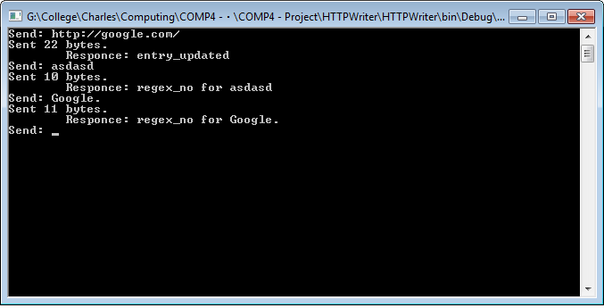

TEST 2 (malicious data)

FORM NAME: Eyespy HQ Authentication
FUNCTION: to allow users to log on
Input | Expected result | Result achieved | Test ref.
DROP TABLE LOGON | Message “Invalid username/password.” | Yes | T4.1
‘’’’#’ | Message “Invalid username/password format.” | Yes | T4.2

Malicious data test, the following messages are issued by Eyespy HQ.
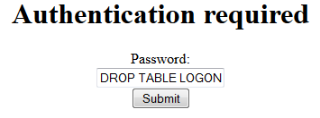
Figure 5 - T4.1 Malicious data input (CAUSE)
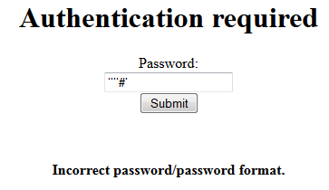
Figure 6 - T4.2, Malicious data response (EFFECT) + invalid input attempted (CAUSE)
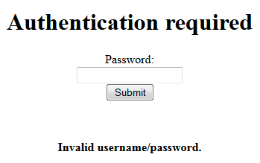
Figure 7. T4 - Invalid data response
TEST 3 (Database data)

Input | Expected result | Result achieved | Test ref.
Link used: “aeriagames.com”  With keywords: “free online games” – as quoted from the HTML source | Link should figure in the database table “entries” and the keyword in the “category” table, both entries should be normalized by the WebsiteCategoryLink table. | Yes | T4.1
Link used: “csharp.net-information.com”  No metadata is present in the HTML source. | Link should figure in the database table “entries” and no | Yes | T4.2

The test below will illustrate data being put through the entire “pipeline”, this means that this test was performed on the to-be host computer of Eyespy Core. The test will be performed in the following way:
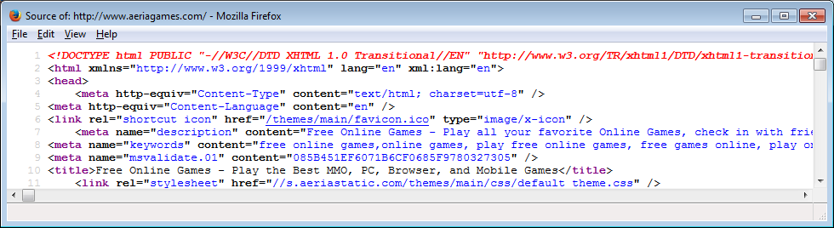
A website will be visited, with a print screen of the URL and associated metadata. Should the data be processed with success, the data will be printed from a) the appropriate database tables and b) the Eyespy HQ page.

- LINK USED FOR TESTING: aeriagames.com
Dump of the HTML header and proof of URL (see window title).
As shown below, Eyespy Core has processed the link and submitted it to the database:

Using the ID as reference, the first keyword defined within the HTML header:
<meta name="keywords" content="free online games”>

Has been inserted into the category table:
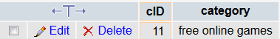

And linked via the link table:
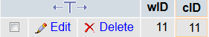

- LINK USED FOR TESTING: csharp.net-information.com

The next example illustrates a website with no metadata being put through the pipeline.

As can be seen in the source code of the site csharp.net-information.com, no metadata is defined within the HTML header. Eyespy handles this data by checking the header for metadata- if no metadata is present, Eyespy will return no metadata, which inserts no category data for that website within the database, so as to save disk space - see below for the progression of the URL through the pipeline:
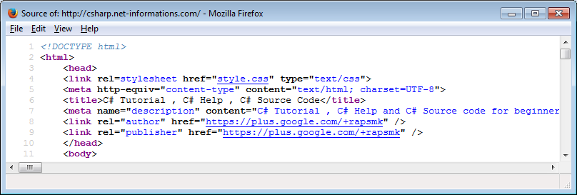
The entry is submitted,

Querying the category table with the ID 12 of the URL, no results are returned- 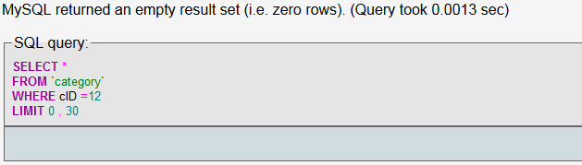
TEST 4 (Data structure test)

Input | Expected result | Result achieved | Test ref.
Link used: “aeriagames.com”  With keywords: “free online games” – as quoted from the HTML source | Link should figure in the database table “entries” and the keyword in the “category” table, both entries should be normalized by the WebsiteCategoryLink table. | Yes | T4.1
Link used: “csharp.net-information.com”  No metadata is present in the HTML source. | Link should figure in the database table “entries” and no | Yes | T4.2

- LINK USED FOR TESTING: s3.reutersmedia.net

s3.reutersmedia.net is reuters.com’s image server, many images are displayed on Reuteurs.com, which means that s3.reutersmedia.net would make its way to the top hitcounted item in very little time.
Here is a stack dump of the link the first time that it get processed -
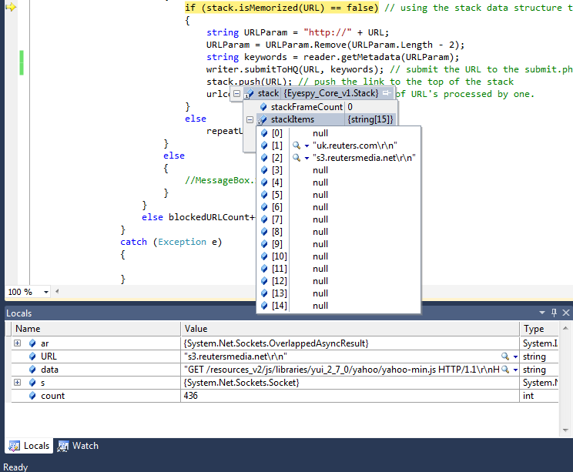

The second time the link is fetched by Eyespy, the stack dump remains the same and the link is ignored, and evaluates to 1, as seen.

The result of these last 4 test are displayed as seen below inside of Eyespy HQ -
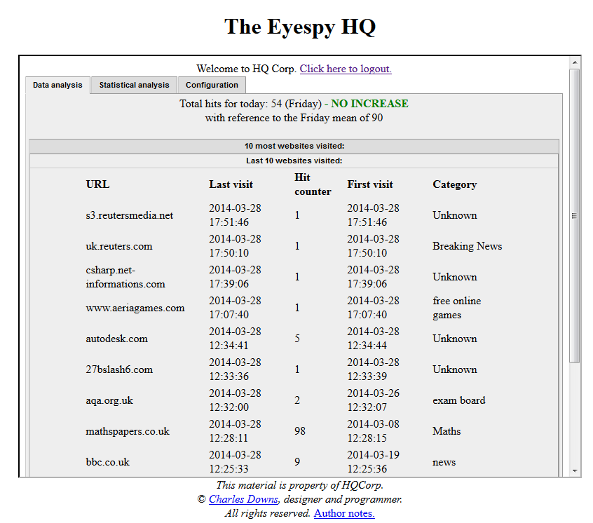

The above image illustrates how the abovementioned tests succeeded and gave the expected results.

- Using the Configuration tab tools

The following tests are to ensure that the “Configuration” tab inside the Eyespe HQ module perform the correct tasks. Each button will be pressed (in the order they appear, from top to bottom) and the effect they have on data will be shown in the following image.

Input | Expected result | Result achieved | Test ref.
Submit button for “Reset hitcounters” | Website hitcounters reset. | Yes | N/A
Submit button for “Delete categories” | Website categories cleared. | Yes | N/A
Submit button for “Delete website entries” | Website entries cleared. | Yes | N/A

Below is the modular configuration interface as it appears in the Eyespy core. These are the tested functions:
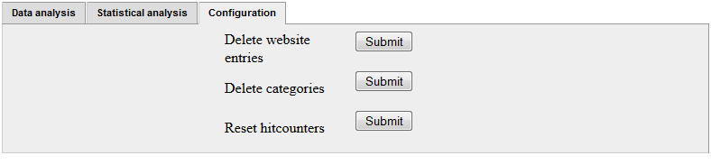

Resetting the hitcounter-
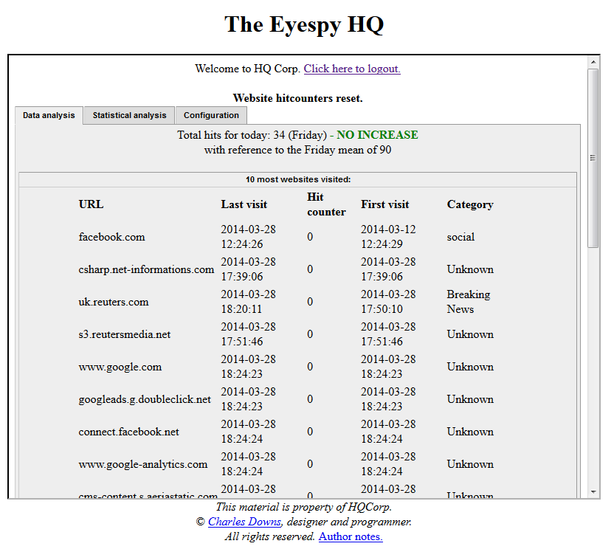
Success message displayed in bold as heading and all hitcounters have been reset to zero.

Deleting website categories-
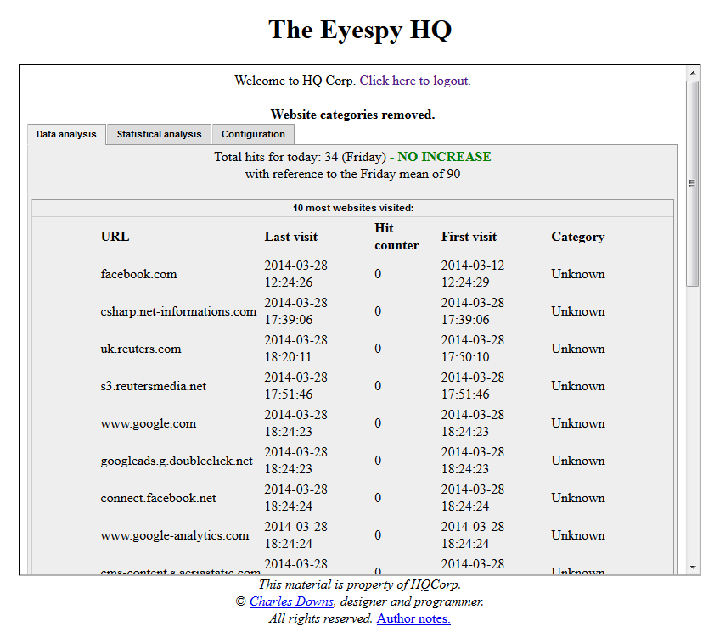

Success message displayed in bold as heading and all categories set to “Unknown”.

Deleting website entries-
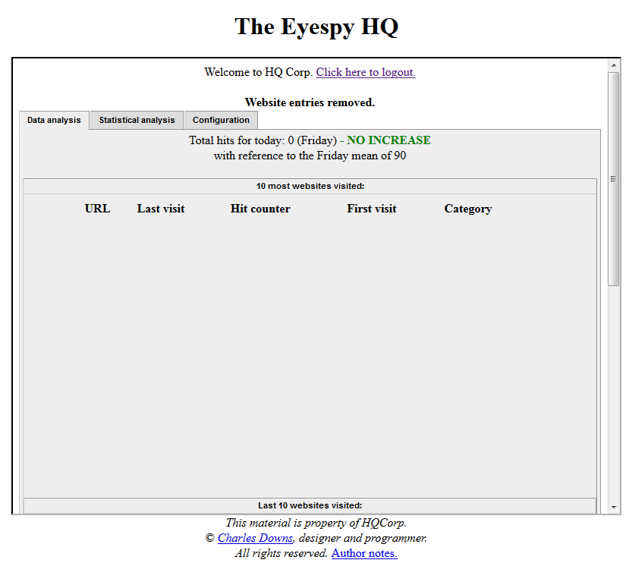
Success message displayed in bold as heading and all website data is removed.

Evaluation of test results

Regarding the testing application I conceived (mentioned in Design, section 16, this application allowed me to test the validation of data that I could directly feed to the Eyespy website submission script, as demonstrated in the second test plan, it served a good purpose to test regex validation of URL’s and their validity/invalidity and existence within the database, the main advantage of conceiving such a program were
- No browser required
- Quick and effective responses based on database queries
- Not required to check the database for existing entries
This sped up preliminary testing as it allowed me to test the effectiveness of the Eyespy HQ submit script.

The following tests were performed on the to-be host computer of my user. For the purpose of testing the program in greater detail, Visual Studio C# was installed on the host computer, which allows for detailed testing, as when debugging we can view stack dumps and trace variables.
The Test 3 (database testing) was performed with the user next to me, so as to evaluate results together and assess their validity and pertinence in context.
Together, we ran Eyespy and browsed to various common websites to make sure data was collected correctly, at the end of the testing we established that Eyespy was working correctly on the host machine, and that data collected was valid in context.
This gave us a general idea of the robustness of the system- with the implementations of the stack data structure, we were greatly able to reduce the amount of ad/image server related links being processed and submitted to the database. This is a very important point, as without this implementation, various ad/image links would become amongst the top visited websites inside Eyespy HQ, which is problematic as it means the user can’t directly evaluate the data.

One of the issues we discussed was the single keyword collected by Eyespy, as sometimes the first keyword listed within the metadata is not the most pertinent to the website, after discussion, we decided the system should take the first 3 keywords.

